Relational Database
- Database engine that RDS supports:
- Postgres
- MySQL
- MariaDB
- Oracle
- Microsoft SQL Server
- IBM DB2
- Aurora
Advantage using RDS over deploying DB in EC2
- RDS is managed service
  - Automated provisioning, POS patching
  - Continuous patching and restore specific timestamp (Point in Time Restore)
  - Monitoring dashboard
  - Read replicas for improve read performance
  - Multi AZ for Disaster Recover
  - Maintenance windows for upgrades
  - Scaling capability (vertical and horizontal)
  - Storage backed by EBS
- BUT you CAN’T SSH to your RDS instances

RDS – Storage Auto Scaling
- Help increase storage of RDS DB instance dynamically
- When RDS detects you are running out of free db storage it scale automatically
- Avoid manually scaling your db storage
- You have to set Maximum Storage Threshold (max limit for DB storage)
- Auto modify storage if:
  - Free storage < 10% of allocated storage
  - Low-storage lasts at least 5 minutes
  - 6 hours have passed since last modification
- Useful for apps with unpredictable workloads
- Support all RDS db engines

RDS Read Replicas
Basically it help you increase your RDS read speed performance
- Up to 15 Read Replicas
- It can be same AZ, Cross AZ or Cross Region
- Replication is ASYNC so reads are eventually consistent
- Replicas can be promoted to their own DB
- Applications must update the convention string to leverage read replicas
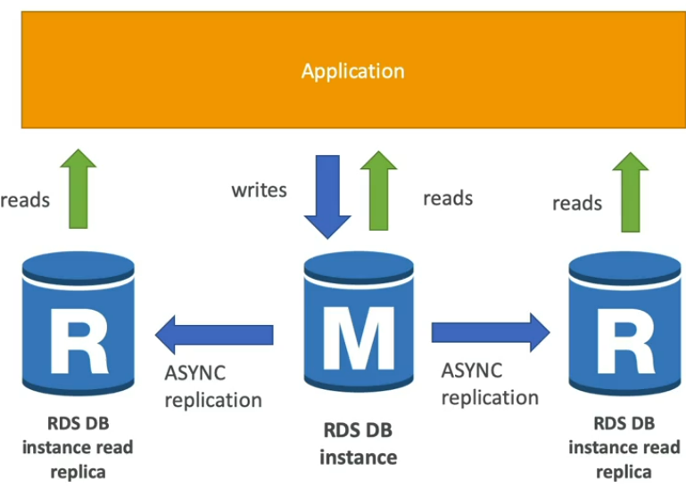
RDS Read Replicas – Use Cases
- Apps that users request a lot of read requests per minute or second like Online News website
- You have production db that is taking on normal load
- You want to run a reporting app to run some analytics
- You create a Read Replicate to run the new worldload
- The production app is unaffected
- Read Replicas are used for SELECT only kind of statements (not INSERT, UPDATE, DELTE).

RDS Read Replicas – Network cost
- AWS charges network cost when data goes from one AZ to another
- For RDS Read Replicas within same region, it free charge

RDS Multi AZ (Disaster Recovery)
- Sync replication: it will replicate all changes synchronously
- One DNS name – automatic app failover to standby
- Increase availability
- Failover in case of loss of AZ, loss of network, instance of storage failure
- Failover: refers to switching to a computer, system, network, or hardware component that is on standby if the initial system or component fails
- No manual intervention in apps
- Not used for scaling
- Note: The Read Replicas can be setup as Multi-AZ for Disaster Recovery (DR)

RDS - From Single-AZ to Multi-AZ
- Zero down time operation
- Just click on modify to update the db
- What will happen internally:
  - A snap is taken
  - A new DB is restored from snapshot in a new Z
  - Synchronization is established between 2 dbs
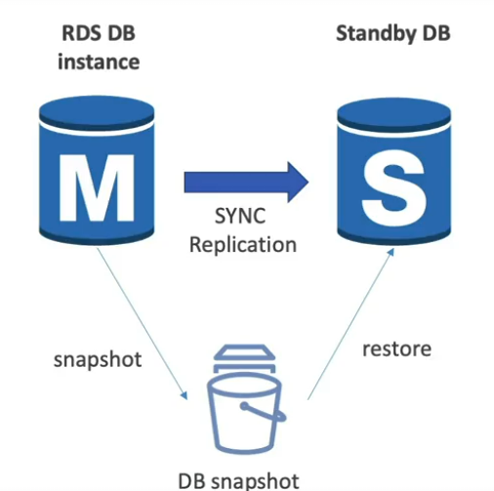

RDS Hands-on
Example DB engine: MySQL
Standard Create
Select Engine options > Engine version
Select Templates: Production; Dev/Test; Free tier
Availability and durability: Multi-AZ DB Cluster; Multi-AZ DB instance;
Single DB instance
Settings:
Input DB Instance name
Input Master username and Master password
Choose Instance type in Instance configuration : Burstable classes
Storage: choose Storage type, Storage auto-scaling
Connectivity:
- You can choose to connect to already exist EC2 instance or Don’t connect to an EC2 to create new instance
- Select VPC, DB subnet group
- Enable or disable Public access
- Config VPC security group(firewall) settings and select Certificate authority
You can pick Database authentication: Password authentication, Password and IAM database authentication, Password and Kerberos authentication
You can choose to Enable Enhanced Monitoring
Advance configuration like:
- Initial DB name, DB parameter group, Option group
- Enable automated backup and Backup retention period
- Encryption: Enable encryption
- Log exports: Audit log, Error log, General log, Slow query log
- Maintainance: Enable auto minor version upgrade is enabled by default
- Enable/Disable Deletion protection
Finally are the Estimate monthly cost review and user can proceed to press Create database after that.

Then download SQL Electron to connect to AWS RDS cuz it allow connect to all RDS engine

RDS Custom
- Managed Oracle and Microsoft SQL Server Database with OS and database customization
- RDS: Automates setup, operation and scaling of db in AWS
Versus
- Custom: access to underling db and OS behind the instance so you can:
  - Configure settings
  - Install patches
  - Enable native features
  - Access the underlying EC instance using SSh or SSM Session Manager
- De-activate Automation Mode before customizing your RDS or better take a DB snapshot to avoid break the RDS
RDS | RDS Custom
Enter db and OS to be managed by AWS | Full admin access to the underlying OS and DB

Amazon Aurora
- Proprietary(adj) p(r)əˈprīəˌterē : mean it exclusive and copyright by certain entity and also protected by the copyright law
- Aurora is a proprietary & copyright technology from AWS
- Postgres and MySQL are both supported as Aurora DB
- Aurora is “AWS cloud optimizer” and claims 5x performance improvement over MySQL on RDS, over 3x performance of Postgres on RDS
- Aurora storage automatically in increment of 10GB up to 128 TB
- Aurora can have up to 15 replicas and the replication process is than MySQL( sub 10ms replica tag)
- Failover: mean automatically back up in case of server failure or data loss
- Failover in Aurora is instantaneous. It’s High Availability native
- Aurora COST MORE than RDS around 20% more – but it more efficient.

Aurora High Availability and Read Scaling
- Automatically store 6 copies of your data across 3 AZ
- One Master and multiple read replicas and the storage will be replicated, self-healing and auto-expanding, little block by little blocks
- Explain: you write data table 1 it will store 6 blue blocks total across 3 AZ with 2 blue blocks each AZ.
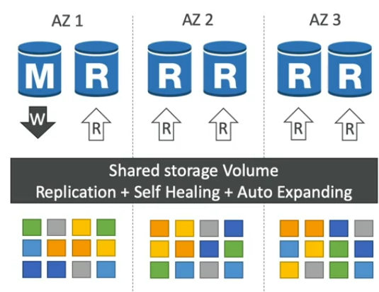

Aurora DB Cluster
Your master is the only thing write to the storage and because master can change and failover so Aurora provide Writer Endpoint that pointing to the master and since it’s a DNS name your Client will always work with and redirected to Writer Endpoint.
You can 1 to 15 Read Replicas and apply Auto Scaling to these Read Replicas. BECAUSE there are to many replicas and hard to keep track of it, Aurora will provide a READER ENDPOINT so these Read replicas and Client can interact with each other through the Reader Endpoint easily
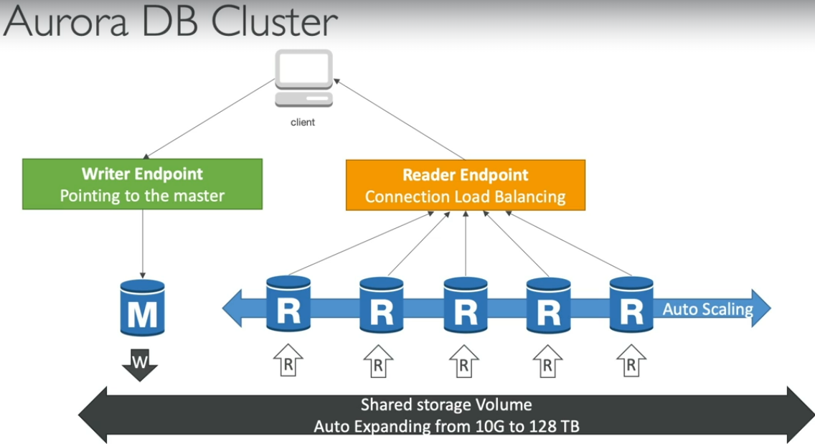

Features of Aurora
- Automatic fail-over
- Backup and Recovery
- Isolation and Security
- Industry compliance
- Push-button scaling
- Automated Patching with Zero Downtime
- Advanced Monitoring
- Routine Maintenance
- Backtrack: restore data at any point of time without using backups

Aurora Hands-on (expensive)
Step 1: Choose DB engine options
- It can either Aurora (MySQL Compatible) or Aurora (PostgreSQL Compatible)
- Select versions
Step 2: Template
- Choose template either Production or Dev/Test
Step 3: Settings
- Input DB cluster identifier name
- Input Master username, master password
Step 4: Cluster storage configuration
- Choose Aurora standard or Aurora I/O-Optimized
Step 5: Instance configuration
- Choose instance type
Step 6: Availability & durability
- You can choose Create an Aurora Replica or Reader node in a different AZ or Don’t create an Aurora Replicate => For Scale Ability
Step 7: Connectivity
- Compute resource: You can choose Don’t connect to an EC2 compute resource or Connect to an EC2 compute resource
- Network type: You can choose IPv4 or Dual-stack mode(Your resource can communicate with IPV4, IPv6 or both)
- Virtual Private cloud (VPC): Select the VPC with suitable amount of subnets and availability zones
- DB subnet group: select the suitable amount of subnets and availability zones
- Public access: select Yes or No to Enable or Disable it
- VPC security group(firewall): Select suitable security groups or create new one with the right configurations to allow Inbound and Outbound traffic to your Aurora DB
- RDS Proxy(optional)
- Database port: default for MySQL is port 3306
Step 8: Enable or disable Read replicate write forwarding
Step 9: Database authentication: choose IAM db authentication or Kerberos authentication
Step 10: Enable or disable Monitoring
Step 11 : Additional configuration
- Initial db name
- DB cluster parameter group and DB parameter group
- Option group
- Failover priority
- Backup:
  - Encryption
  - Log export
  - Deletion Protection
Step 12: Review estimated costs and Create database
Result:
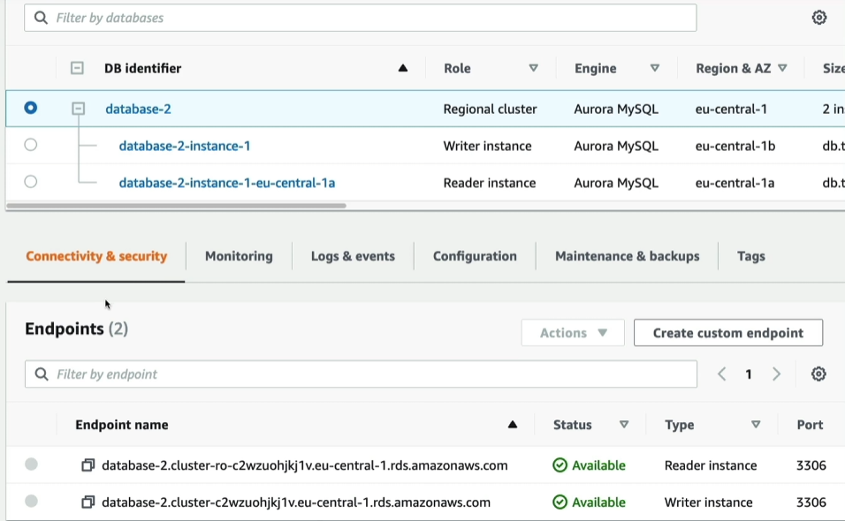
- We have reader and writer endpoint just like the diagram Aurora DB cluster has shown (Writer Endpoint for Master, Reader Endpoint for Replicas)

Replica auto-scaling
- Config Policy details: policy name, IAM role, Target metric(Average CPU utilization of Aurora Replicas, Average connection of Aurora Replicas)
- Cluster capacity details: To set min and max capacity of Replicas scaling.
- If you want to add more AWS region for your Aurora DB you will need to change instance type to large to add more region to your Aurora DB
- For deletion: You will need to delete the Aurora DB’s Writer and Reader endpoints first then you safely remove Aurora DB

Aurora – Advance Concepts

Aurora Replicas – Auto Scaling
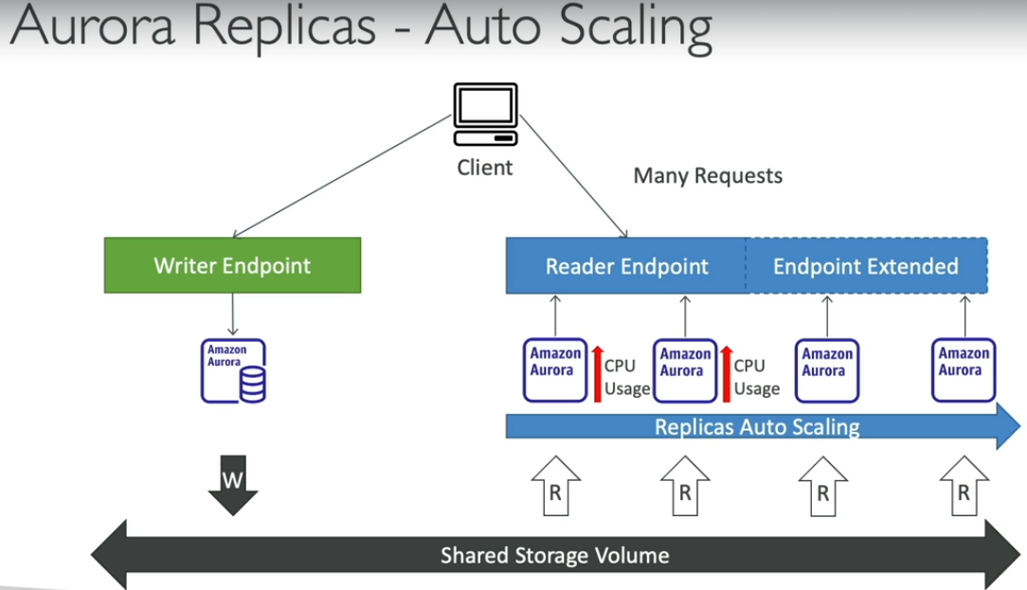
We have many requests on Reader endpoint that lead to increasing in CPU Usage and with Replicas Auto Scaling it will create more Replicas to balance the CPU usage Reader endpoint will also be extended to cover these news replicas and distributes traffic evenly among all old and new replicas.

Aurora – Custom Endpoints
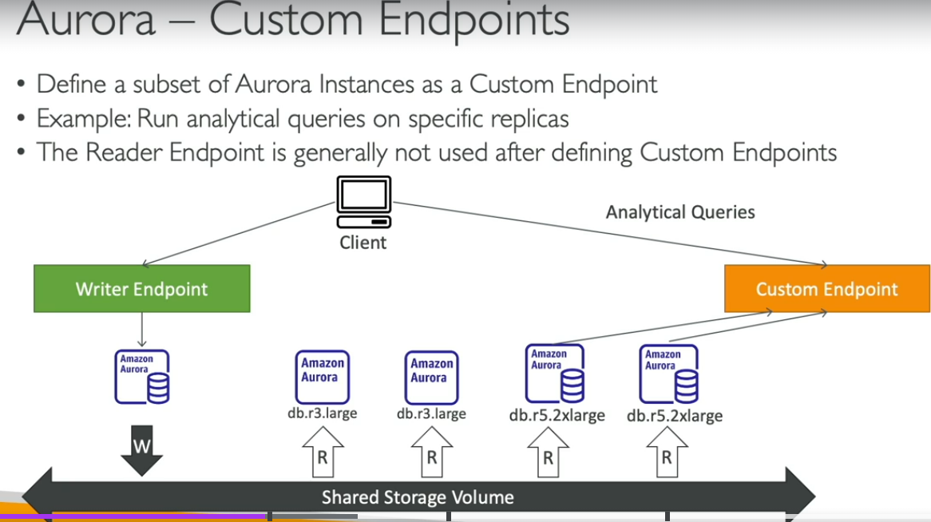
- This same setup has 2 different kinds of replicas db.r3.large and db.r5.xlarge
- The reason because some replicas like db.r5.xlarge are bigger than other
- You would want to define a subset of your Aurora instances as a custom endpoint because:
  - These instances are more powerful and they’re better to run analytical queries on these specific replicas
  - Define many custom endpoints for many different kinds of workloads
  - With custom endpoints allowing you to query only a subsets of your Aurora replicas

Aurora Serverless
• Automated database Client instantiation and autoscaling based on actual usage
• Good for infrequent, intermittent or unpredictable workloads
• No capacity planning needed
• Pay per second, can be more cost-effective
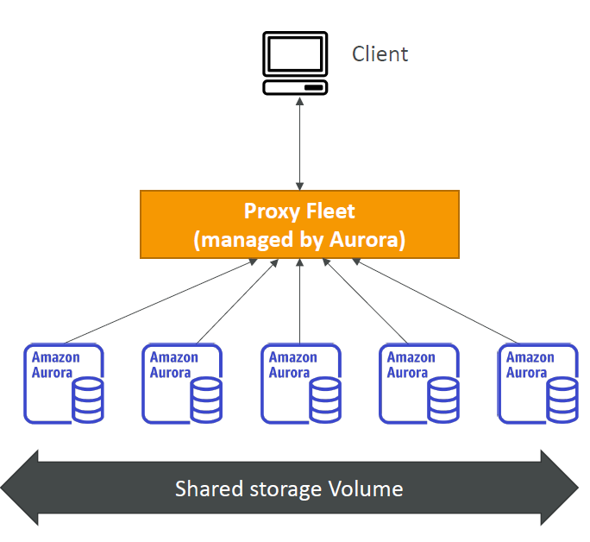

Global Aurora
- Aurora Cross Region Read Replicas:
  - Useful for disaster recovery
  - Simple to put in place
- Aurora Global database(recommended):
  - 1 Primary region (read/write)
  - Up to 5 secondary (read-only) regions. Replication lag is less than 1 second
  - Up to 16 Read Replicas per secondary region
  - Help reduce latency
  - Promoting another for discover recovery has an ROT < 1 minute
  - Type cross-region replication takes less than 1 minute
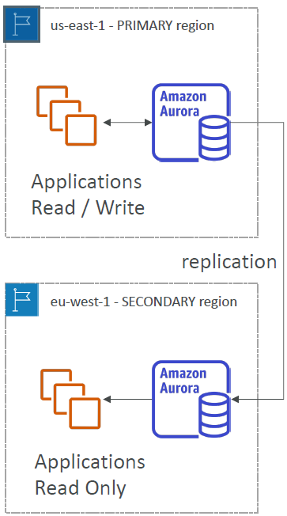

Aurora Machine Learning
• Enables you to add ML-based predictions to your applications via SQL
• Simple, optimized, and secure integration between Aurora and AWS ML services
• Supported services
• Amazon SageMaker (use with any ML model)
• Amazon Comprehend (for sentiment analysis)
• You don’t need to have ML experience
• Use cases: fraud detection, ads targeting, sentiment analysis, product recommendations
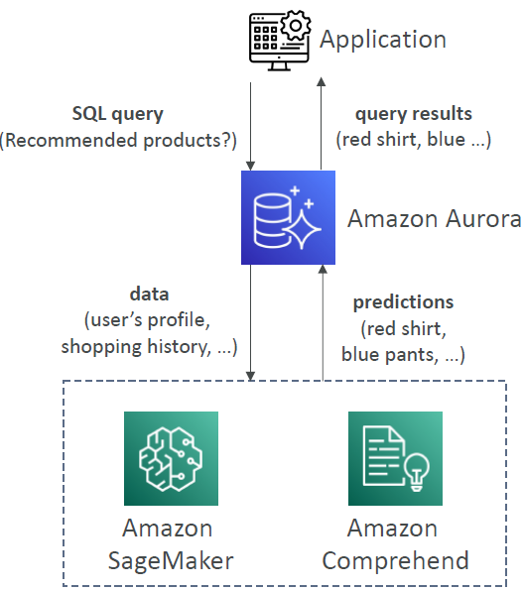

RDS Backups
Automated backups:
- Daily full backup of db
- Transaction logs are backed-up by RDS every 5 minutes Ability to restore to any point in time (from oldest backup to minutes ago)
Manual DB Snapshots:
- Manually triggered by user
- Retention of backup for as long as you want
Trick: in a stopped RDS db you still pay for storage cost. If you planning on stopping it for long time, you should use snapshot & restore instead.

Aurora Backups
Automated backups:
- 1 to 35 days (cannot be disabled)
- Point-in-time recovery in that timeframe
Manual DB snapshots
- Manually triggered by user
- Retention of backup for as long as you want

RDS & Aurora Restore options
- Restoring a RDS / Aurora backup or a snapshot creates a new database
- Restoring MySQL RDS database from S3
  - Create a backup of your on-premises database
  - Store it on Amazon S3 (object storage)
- Restore the backup file onto a new RDS instance running MySQL
- Restoring MySQL Aurora cluster from S3
  - Create a backup of your on-premises database using Percona XtraBackup
  - Store the backup file on Amazon S3
  - Restore the backup file onto a new Aurora cluster running MySQL

Aurora Database Cloning
- Create a new Aurora DB cluster from existing one
- Faster than snapshot & restore
- Use copy-on-write protocol
  - Initially, new DB cluster uses the same data volume as original DB cluster (faster and efficient since no copying needed)
  - When update s are made to new DB cluster, additional storage is allocated and data is copied to be separated
- Very fast & cost-effective
- Useful to create a “staging” db from a “production” db without impact the production db.
RDS & Aurora Security
- At-rest encryption:
  - DB master & replicas encryption using AWS KMS – must be defined at launch time
  - If master is not encrypted, the read replicas cannot be encrypted
- In-flight encryption: TLS-ready by default, use AWS TLS root certificates client-side
- IAM authentication: IAM roles connect to your DB is 1 of the option
- Security Groups: Control Network access to your RDS/ Aurora DB
- No SSH available except on RDS custom
- Audit logs can be enabled and sent to CloudWatch logs for longer retention

Amazon RDS Proxy
• Fully managed database proxy for RDS
• Allows apps to pool and share DB connections established with the database
• Improving database efficiency by reducing the stress on database resources (e.g., CPU, RAM) and minimize open connections (and timeouts)
• Serverless, autoscaling, highly available (multi-AZ)
• Reduced RDS & Aurora failover time by up 66%
• Supports RDS (MySQL, PostgreSQL, MariaDB, MS SQL Server) and Aurora (MySQL, PostgreSQL)
• No code changes required for most apps
• Enforce IAM Authentication for DB, and securely store credentials in AWS Secrets Manager
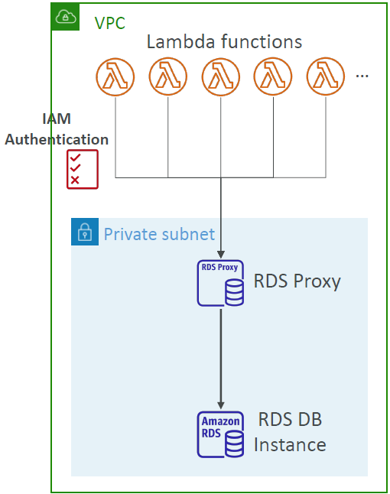
• RDS Proxy is never publicly accessible (must be accessed from VPC)

Amazon Elastic Cache
Behave the same way RDS get managed RDS
To manage Redis or Memcached
Caches are in-memory databases with really high performance, low latency
Help reduce load off of databases for read intensive workloads
Helps make your app stateless
AWS take care of OS maintenance/ patching, optimizations, setup, configuration, monitoring, failure recovery and backups
Using ElastiCache involves heavy application code changes

ElasticCache Solution Architecture – DB cache
• Applications queries ElastiCache, if not available, get from RDS and store in ElastiCache.
• Helps relieve load in RDS
• Cache must have an invalidation strategy to make sure only the most current data is used in there.
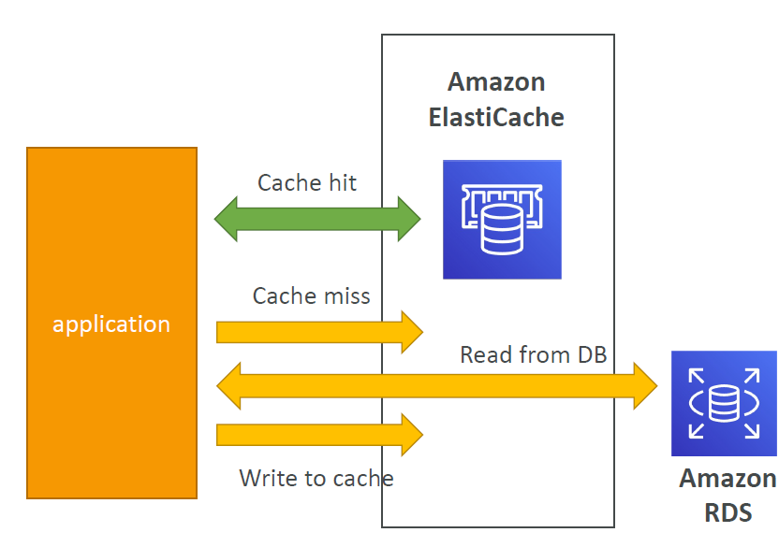

ElasticCache Solution Architecture – User Session Store
Example:
- User login to any of the application
- The application writes the session data into ElastiCache
- The user hits another instance of the application like press on “Go to cart” function
- The instance retrieves the data and the user is already logged in
ElasticCache – Redis vs Memcached
REDIS | MEMCACHED
Multi AZ with Auto-Failover | Multi-node for portioning of data
Read Replicas to scale reads and have HIGH AVAILABILITY | NO HIGH AVAILABILITY
Data durability using AOF persistence | Nom persistent
Backup and restore features | No backup and restore
Support Sets and Sorted Sets | Multi-threaded architecture

ElastiCache – Hands on
Step 1: Cluster settings
Configuration:
Deployment option: Serverless, Design your own cache (select)
Create method: Easy create, Cluster cache(select), Restore from backup
Cluster mod: Disabled
Cluster info: Input cluster Name
Location: AWS Cloud(select) or On premises
Multi-AZ or Auto-failover
Cluster settings:
Engine version, Port number, Parameter groups
Node type: Ex: cache.t2.micro
Input Number of replicas
Subnet group settings:
Create a new subnet (select) or Choose existing subnet group
VPC ID: choose suitable VPC with enough amount of AZ you need
Availability Zone placements: No preference
Then press Next
Step 2: Advance settings
Security
You can enable/disable Encryption at rest to add Encrypt key
You can Enable/disable Encryption in transit to pick suitable Access control method
Access control provides the ability to configure authenticating and authorizing access
Access control type: no auth, AUTH default user access(token), User group access control list
Security groups(Optional)
Enable/disable Backup
Enable/disable Maintenance
Enable/disable Logs
Step 3: Review and create ElastiCache
